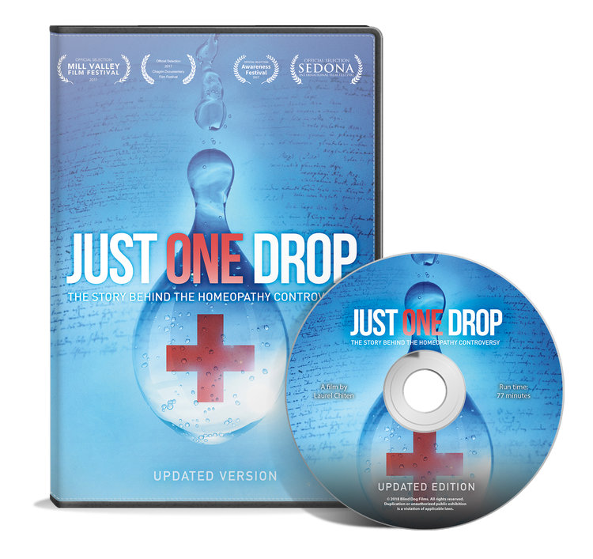

Need more info?

Contact Sue Townsend RShom, Homeopath, Dyce.

sue@townsendhom.com

FREE MOVIE SCREENING with Q n A

3pm Sunday 24th March 2019

Newton Dee auditorium Phoenix Centre

**Just One Drop tells the little known story of homeopathy: the most controversial system of medicine ever invented.**

Homeopathy is a specific form of medicine that uses minute doses of a highly diluted substance that stimulates the body to cure itself. To many, homeopathy seems implausible. They fear it is purely a placebo effect or worse, a form of deception or quackery. Yet, homeopathy has been around for over 200 years and is used by millions worldwide. The film explores the controversy, dispels myths and misconceptions, and asks whether or not homeopathy has been given a fair shake.

The film's ultimate message is about freedom of choice in healthcare.

## 

**Newton Dee Auditorium** (donations welcome)

Newton Dee Village, Bieldside, Aberdeen. AB15 9DX